## Act 1:

A large fleet of Federation ships head towards Deep Space 9 to stop the Dominion destroying the Wormhole minefield. A Dominion fleet meets them in battle.

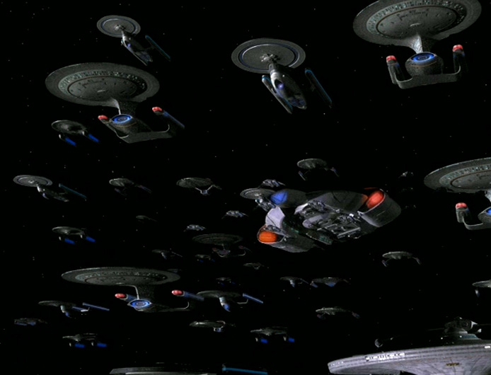

The fleet prepares for its assault on the Dominion Fleet, outnumbered 2 to 1

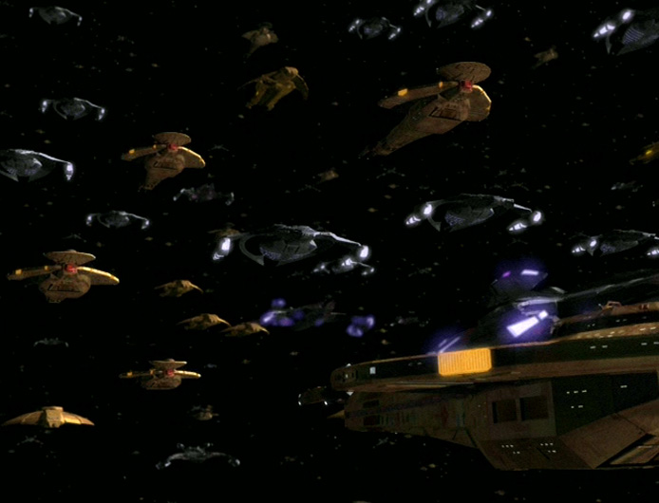

Groups of Federation attack fighters will make strafing runs at the blockade, focusing their fire only on the Cardassian ships hoping to provoke the Cardassians into breaking formation and opening a hole in the Dominion lines. It is the only chance the Federation has of reaching Deep Space 9 before the minefield is taken down and the Dominion

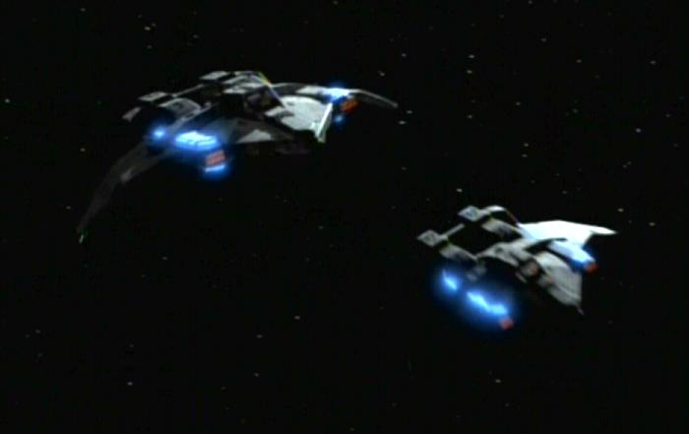

## Act 2:

The Cardassians stand their ground after the fighters' first run, the second and third waves of fighters move forward. They continue to press the Cardassians – the ninth wave of fighters proves just as ineffective as the previous eight. Then half a dozen squadrons to pursue the next group of attacking ships, pulling them out of formation and creating an opening.

"All other ships, head for that opening. Anyone who gets through doesn't stop until they reach Deep Space Nine."

Galaxy-class starships engage Galors. The Federation fleet leaps forward, weapons blazing

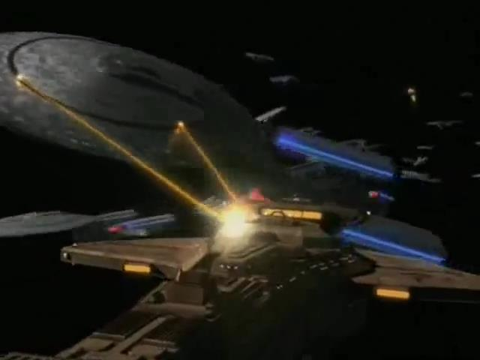

The Defiant, flanked by two Miranda-class vessels, heads into the heart of the blockade fleet, taking multiple hits. The battle descends into a frantic melee

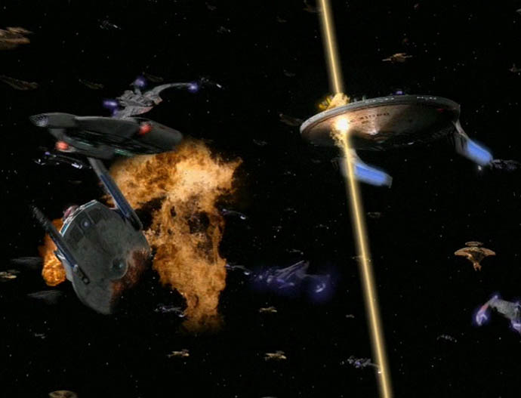

### Act 3:

Four Jem'Hadar attack ships are directly ahead, the Defiant fights its way through. Destroying one fighter, the Defiant is pursued by the remaining three. Just then, a fleet of Klingon ships emerges from the blinding light of the system's sun, hammering into the Dominion fleet.

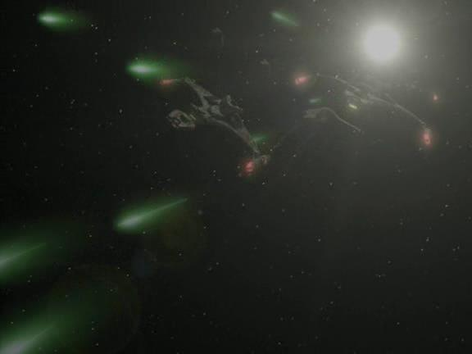

With the Klingons reinforcing the assault, a real opening has appeared in the enemy lines, and the Defiant weaves its way through the battle, emerging alone in the wake of an exploding Jem'Hadar battle cruiser.

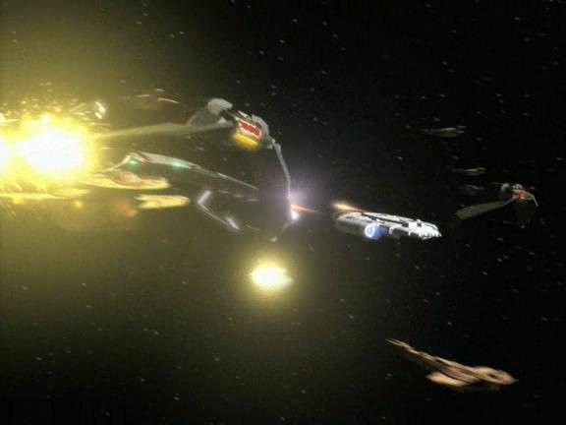

### Act 4:

The Defiant heads to Deep Space 9 while the rest of the fleet fights. The Defiant arrives but the mine field is destroyed. The wormhole aliens nevertheless stop the dominion reinforcements from using the worm hole. The Defiant then opens fire on the defenceless Deep Space 9 that has been sabotaged.

The battle has begun to turn the way of the Allies. The Klingons have outflanked the Dominion blockade fleet, and their lines are starting to crumble. Two hundred Allied ships have broken through their lines and head to Deep Space 9. The station is evacuated and with no hope of reinforcement the Dominion fleet goes into full retreat.

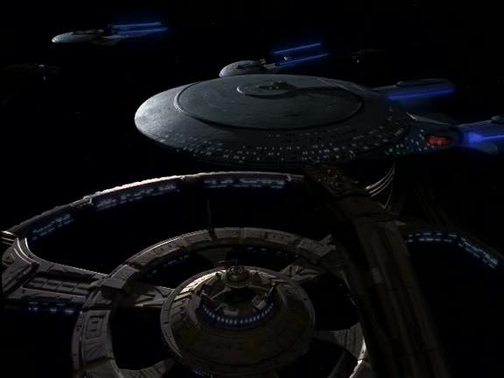

## List of Ships

##### Federation/Klingon:

Star Fleet Attack Fighters

Defiant

Galaxy

Miranda

Akira

Excelsior

Nebula

Vor'cha

Bird of Prey (B’Rel)

##### Dominion:

Galor-class

Hideki

Jem'Hadar fighter

Jem'Hadar battle cruiser

Deep Space 9